**Music Data Analysis**

**About the project:**

This project work includes analysis of large amount of data received from varieties of sources namely from mobile app and website periodically after every 3 hours, to track the behaviour of users, to classify the users, to calculate royalties associated with the song and to make appropriate business strategies.

**Dataset:**

* Data coming from web applications resides in /data/web and has **xml** format.
* Data coming from mobile applications resides in /data/mob and has **csv** format.
* 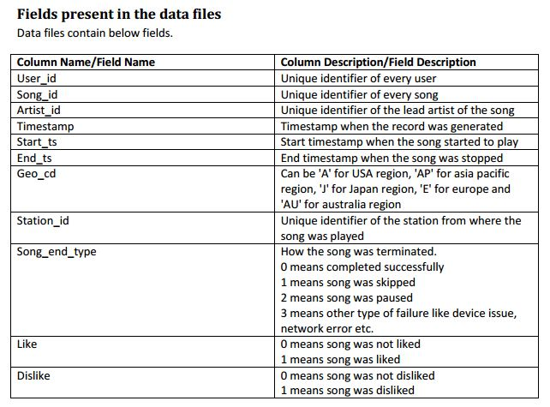Data present in lookup directory is stored in **HBase** tables.

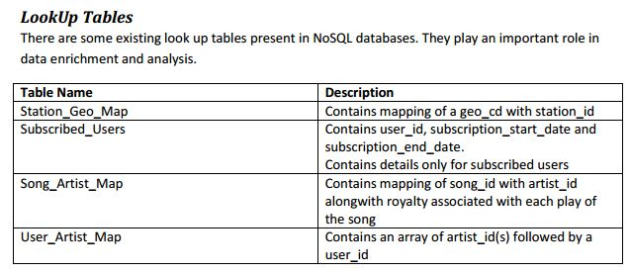

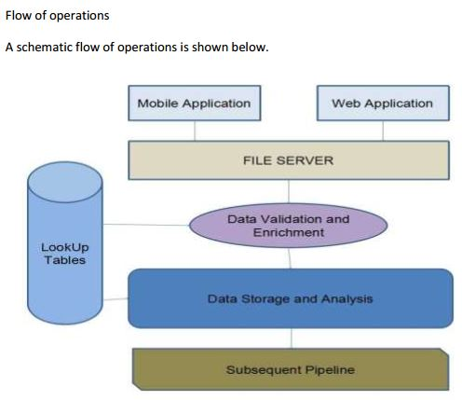 **Flow of Operations:**

**Data Ingestion**

**(Stage - 1)**

**Data Formatting**

**(Stage - 2)**

**Data Enrichment and Filtering**

**(Stage – 3)**

**(Stage - 2)**

**Data Analysis**

**(Stage - 4)**

**Data Storage**

**(Stage - 5)**

**Low Level Design**

**High Level Design**

**(Stage - 1)**

**Data Ingestion**

* **Storage of raw data to HDFS**

**(Stage - 2)**

**Data Formatting**

* **Collection of web data and mob data in Hive Table**
* **Tools Used: Pig and Hive**

**(Stage – 3)**

**Data Enrichment and Filtering**

* **Use of Lookup Tables to enrich the raw data**
* **Segregation of valid and invalid data**

**(Stage - 4)**

**Data Analysis**

* **Analysis of valid data in Spark**
* **Creation of Hive tables to store analysed data**

**(Stage - 5)**

**Data Storage**

* **Export of Analyzed data from Hive to MySql**

**Implementation of Project:**

1. 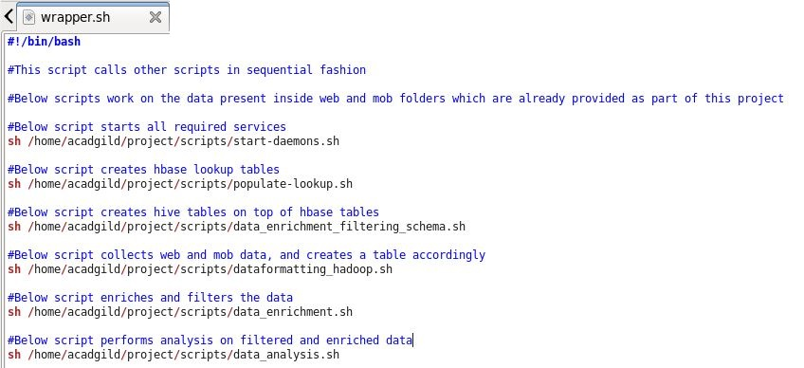**Below script wrapper.sh calls other scripts in sequential manner**
2. 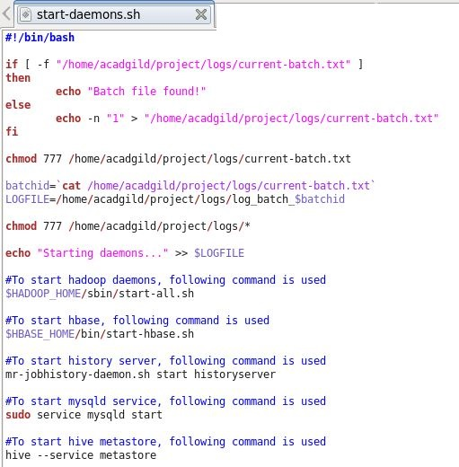**Below script start-daemons.sh starts all the required daemons**

**All process started successfully**

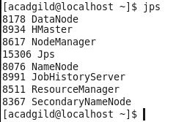

1. 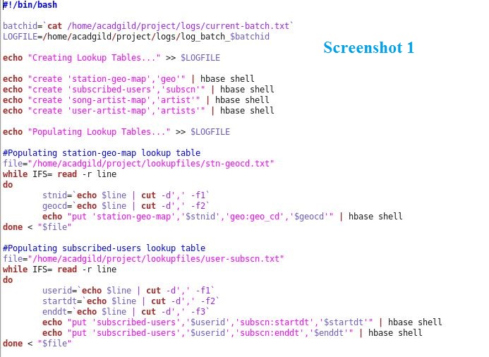**Below script populate-lookup.sh creates lookup tables in hbase [NOSQL Database]**

**[Please refer next page for Screenshot 2]**

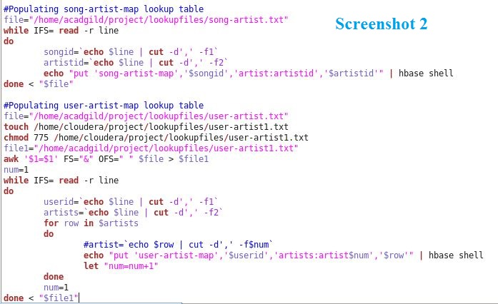

**Below screenshot shows “execution of populate-lookup.sh”**

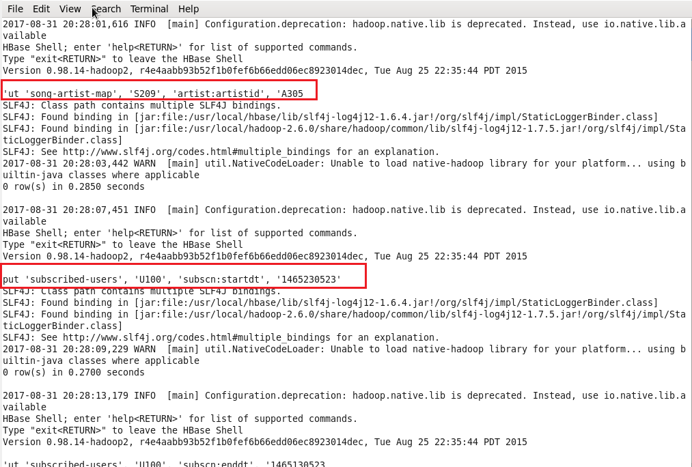

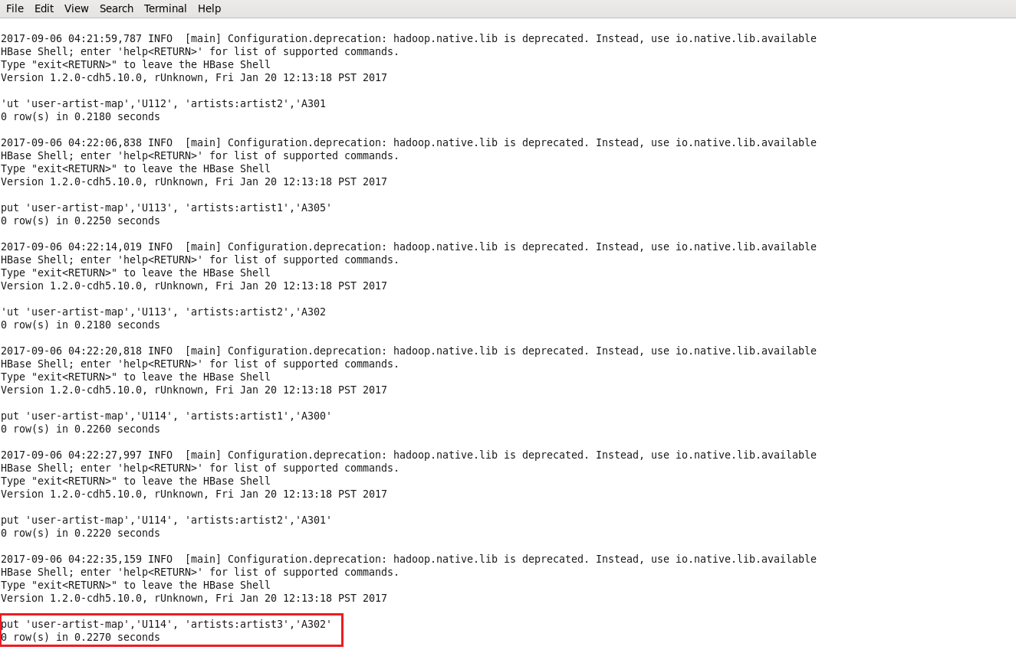

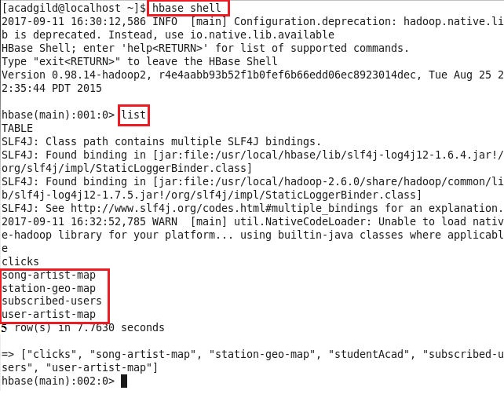**Below screenshots show that lookup tables created successfully inside hbase:**

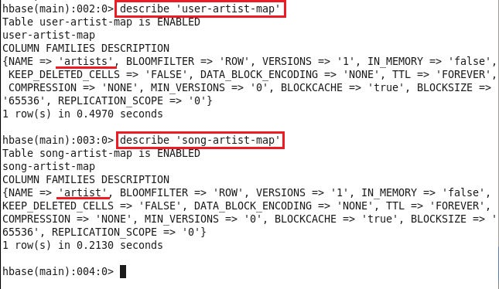

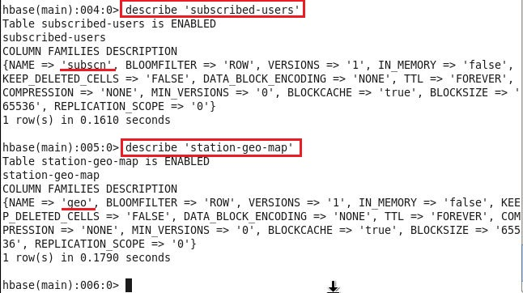

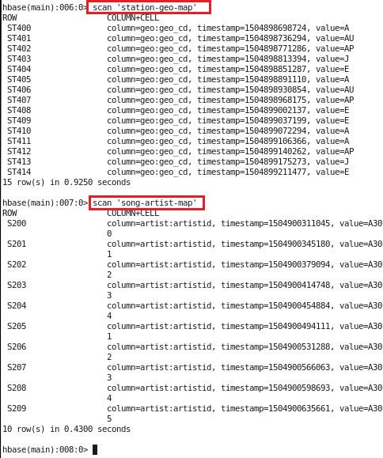

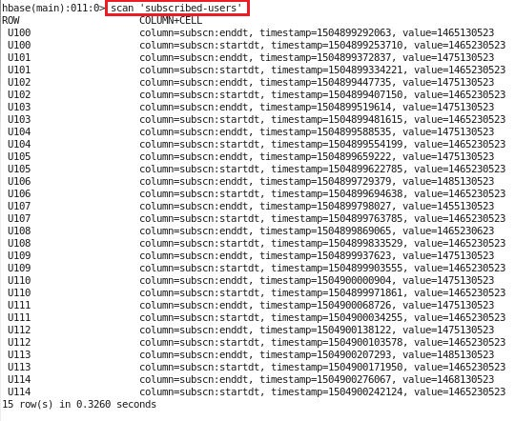

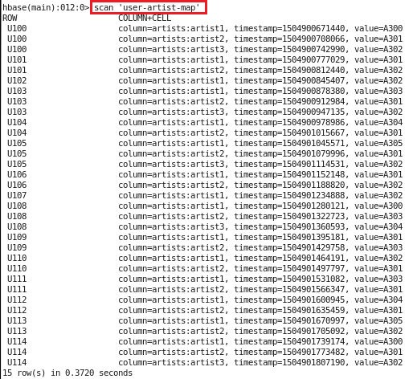

1. 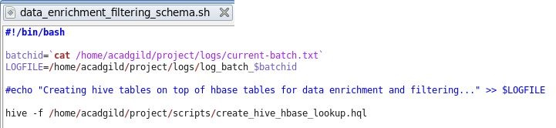**Below script data_enrichment_filtering_schema.sh calls create_hive_hbase_lookup.hql script which creates hive tables on top of hbase tables**

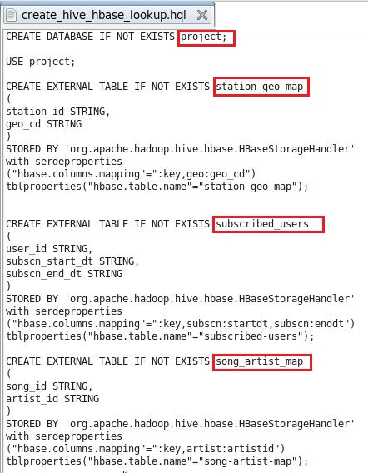

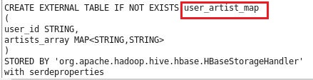

**Below screenshots show that all tables in hive created successfully**

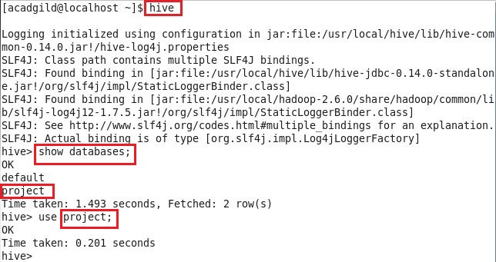

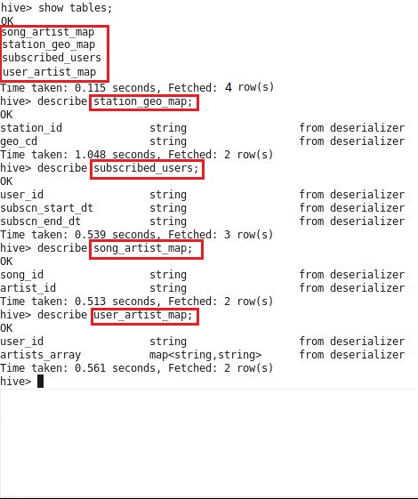

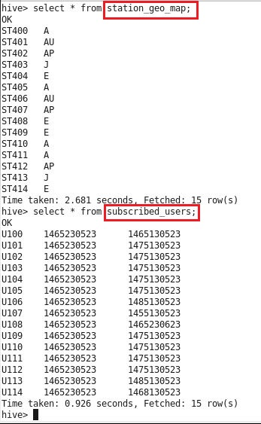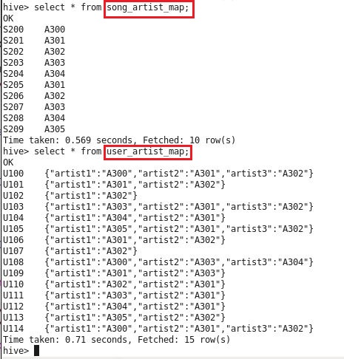

1. 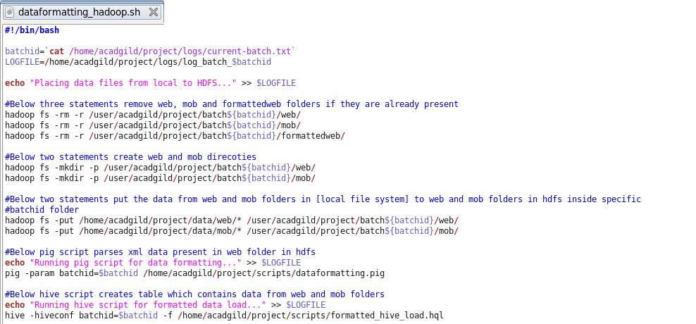**Below script dataformatting_hadoop.sh places data from local file system to hdfs**

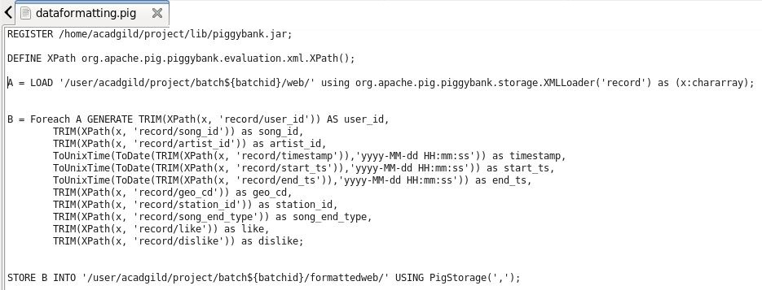**Above script calls dataformatting.pig and formatted_hive_load.hql scripts**

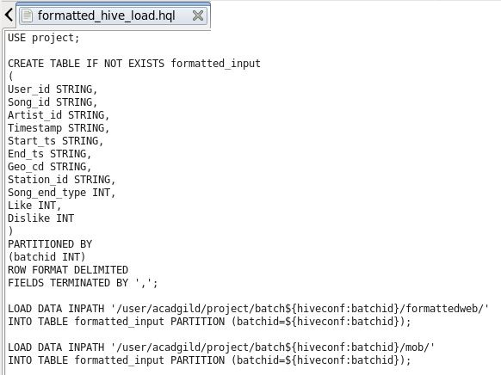

**Below screenshots show that data has been placed successfully inside hdfs**

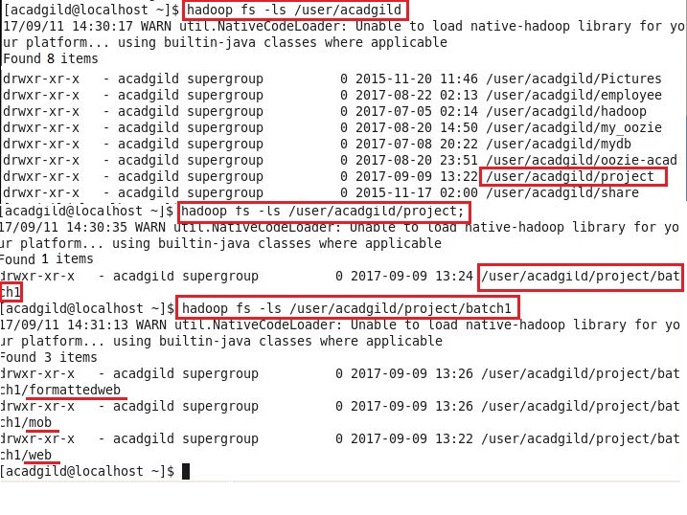

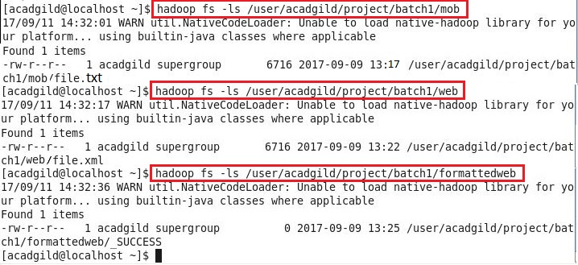

**Below screenshots show that formatted_input table is created successfully in project database inside hive**

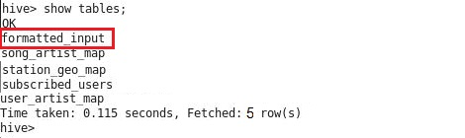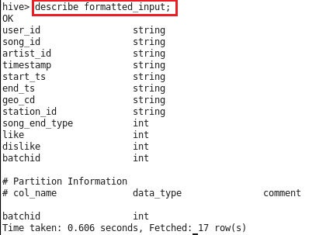

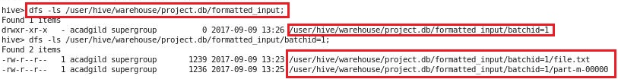

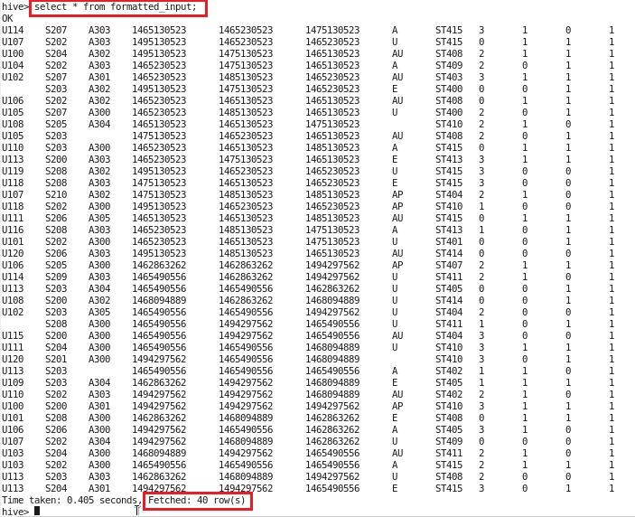

1. **Below script data_enrichment.sh filters and enriches the data of formatted_input table present in hive**

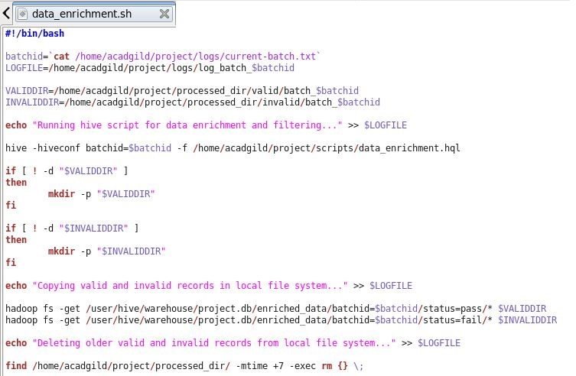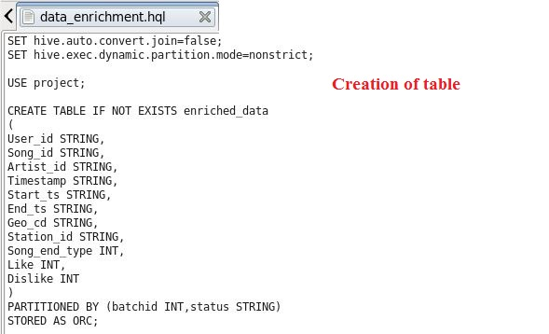

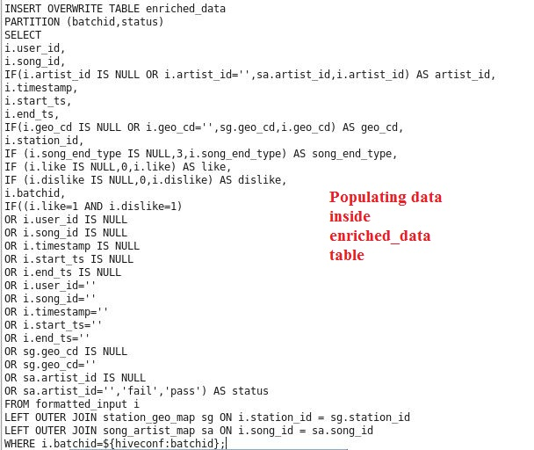

**Below screenshots show that enriched_data table created successfully in project database in hive**

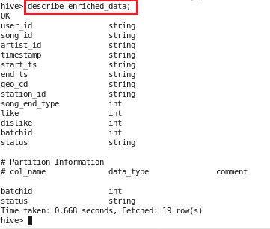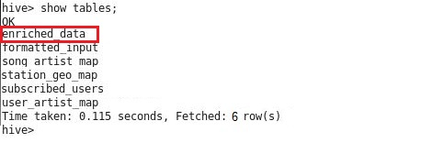

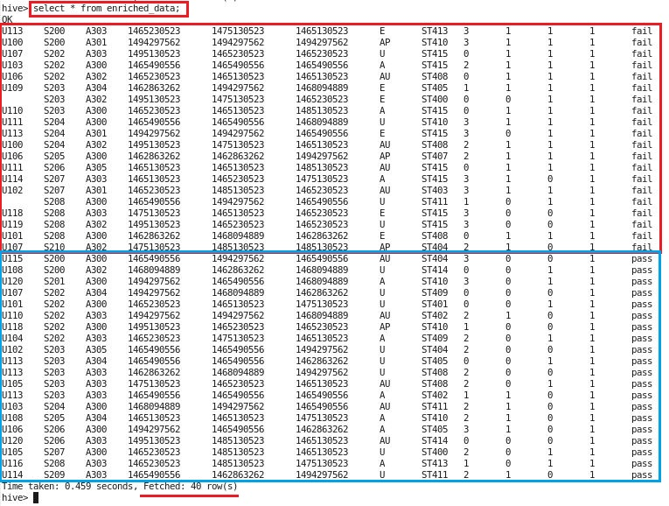**Below screenshot shows that failed (invalid) and passed (valid) data are segregated successfully**

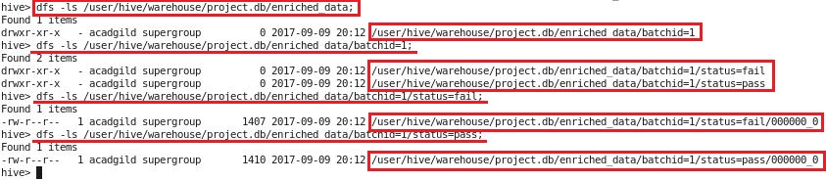

1. **Below script data_analysis_spark.sh performs following steps:**

* **creates hive table using spark**
* **populates the data in hive tables using spark**
* **selects the specific data from spark**

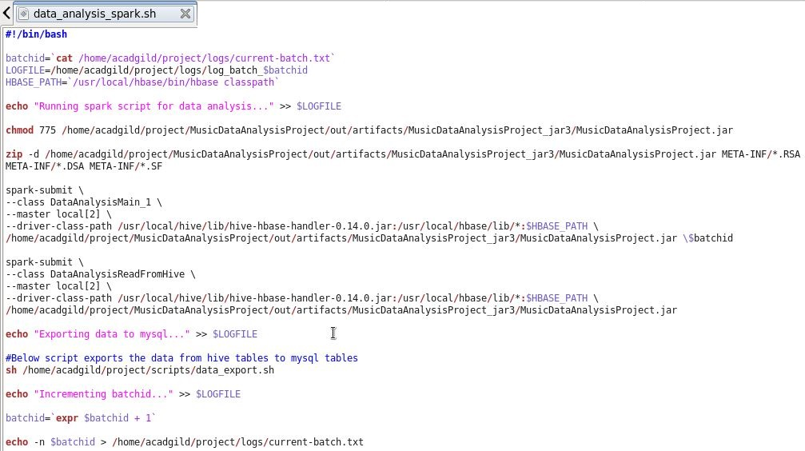

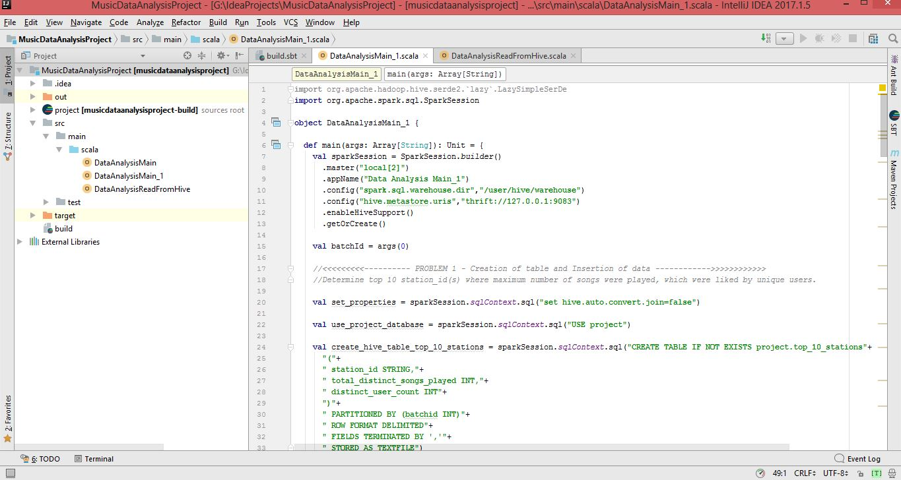**Spark Code to create hive tables and to insert data to hive tables: [DataAnalysisMain_1.scala]**

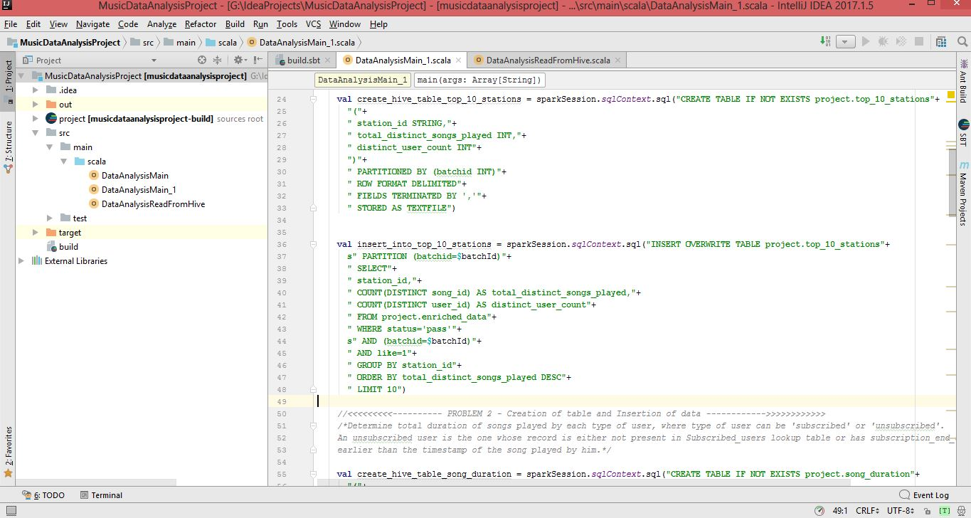

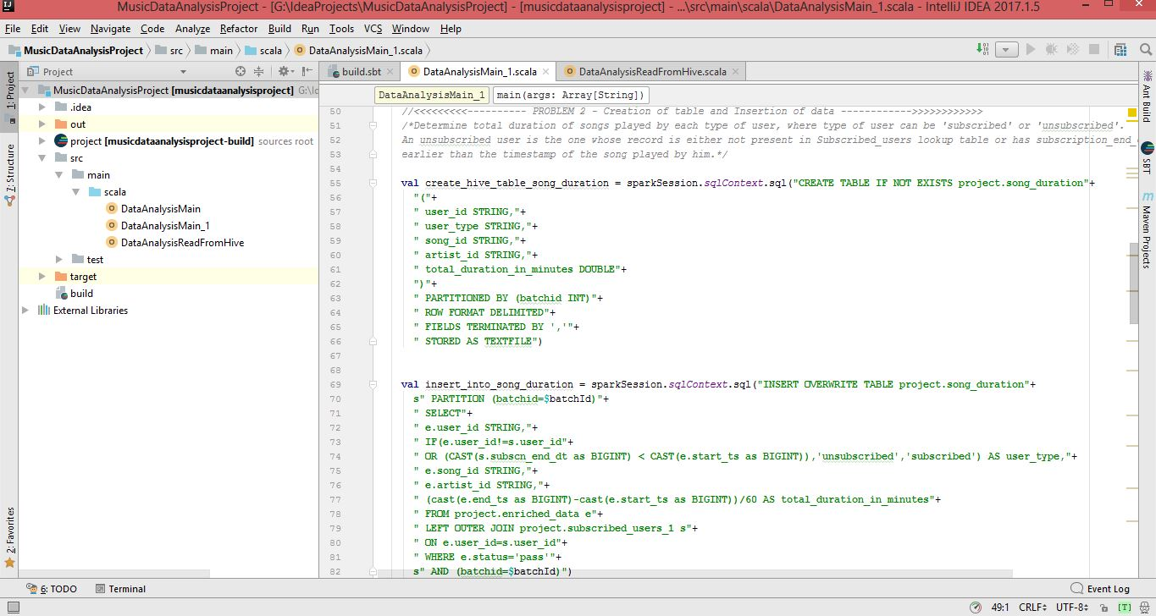

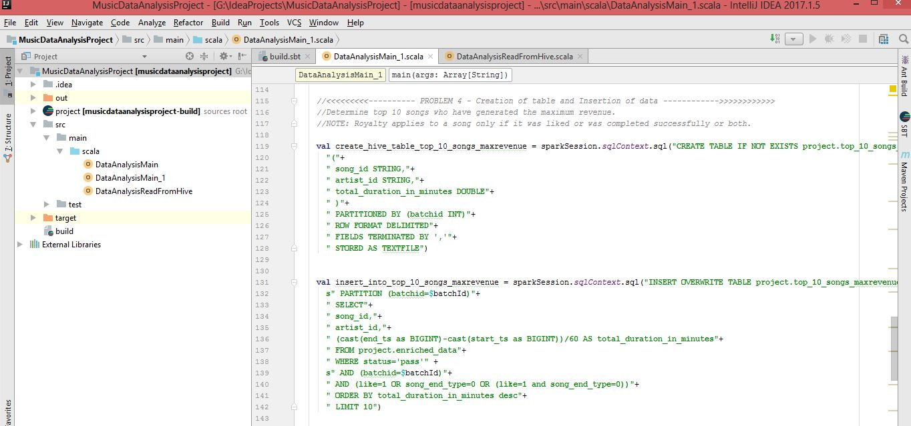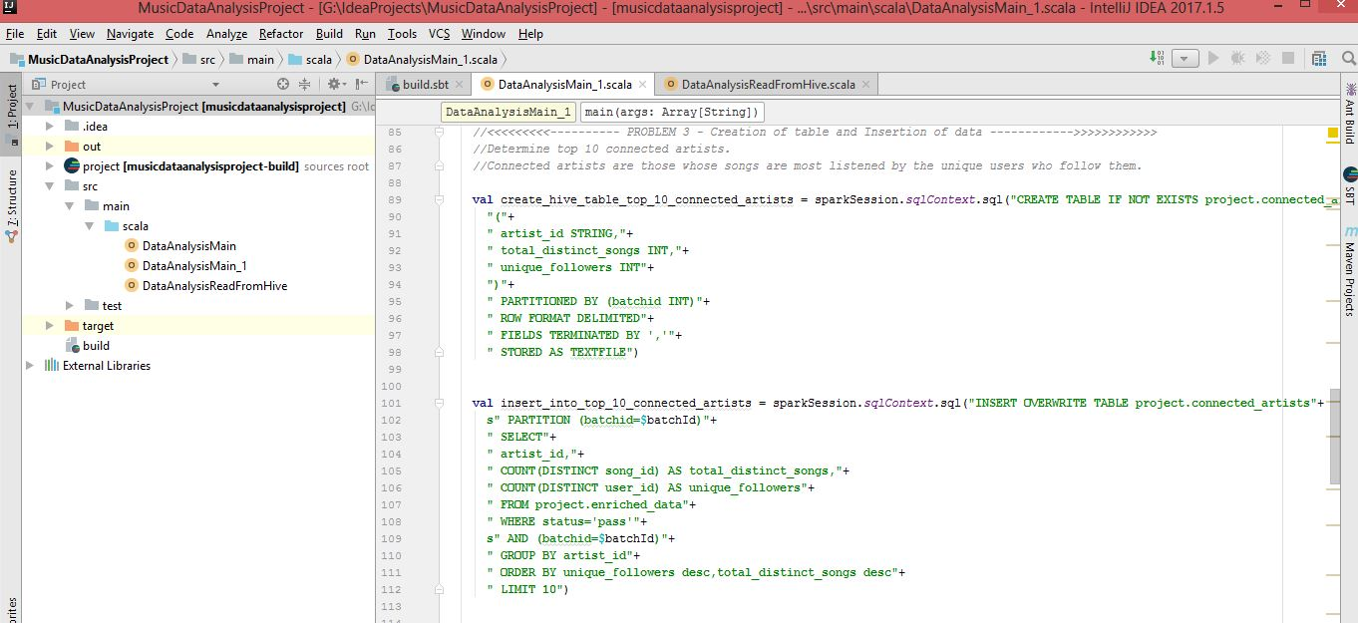

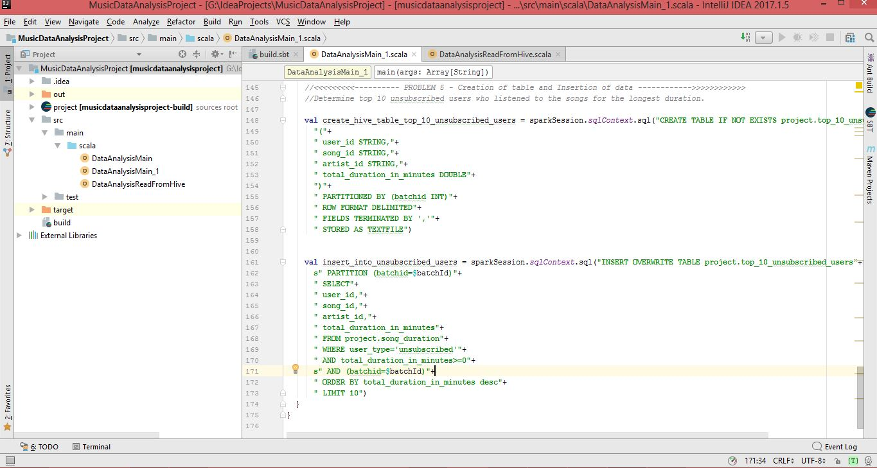

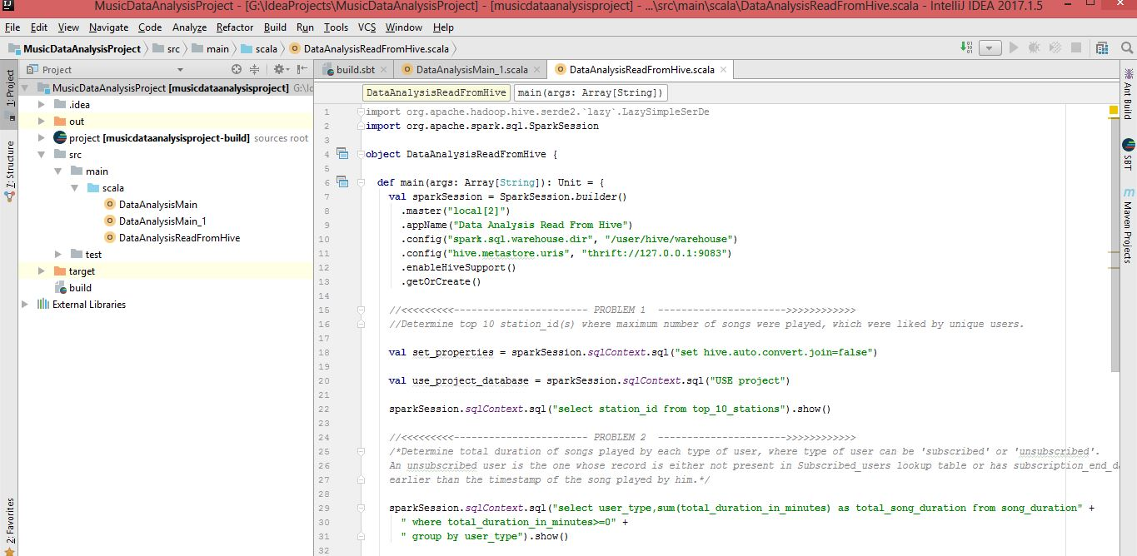**Spark Code to fetch data from hive tables [DataAnalysisReadFromHive.scala]**

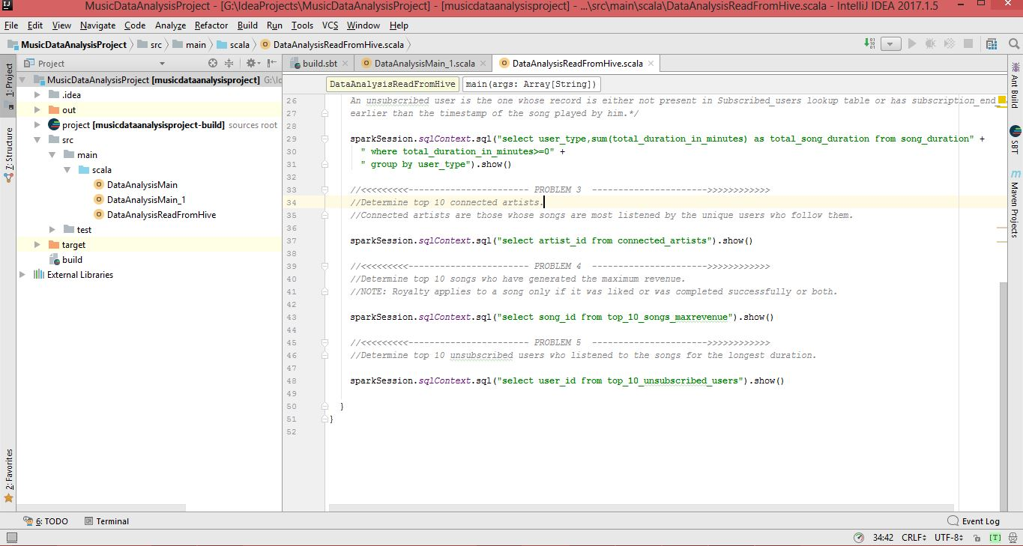

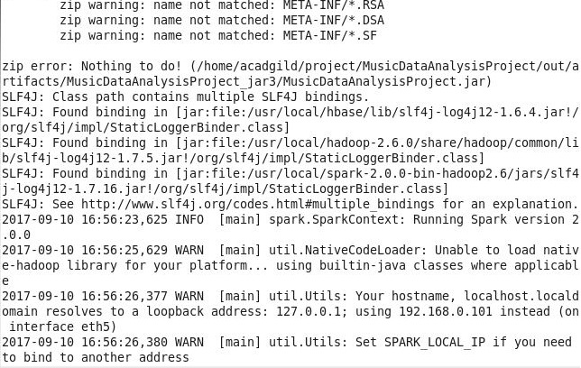 **Below screenshot shows execution of data_analysis_spark.sh**

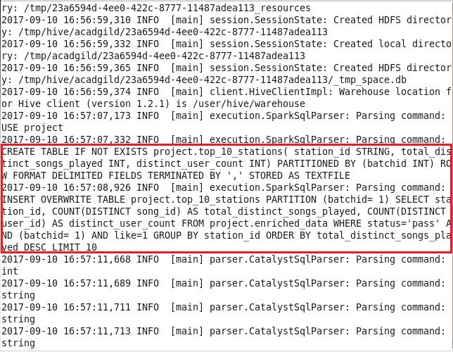

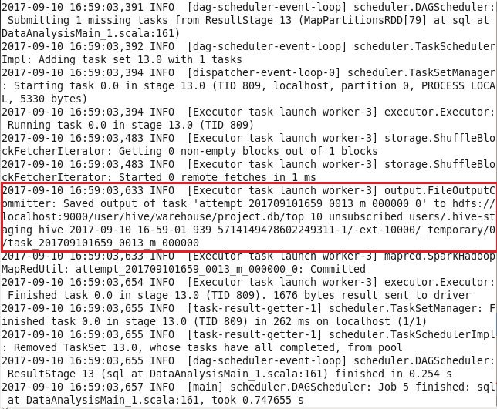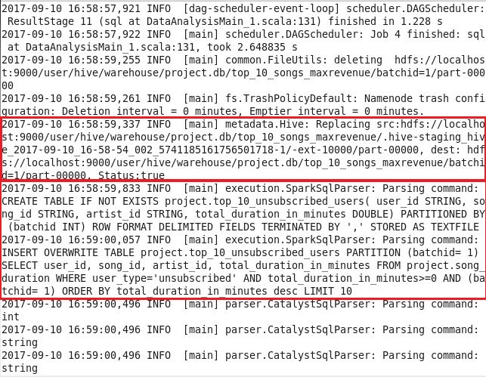

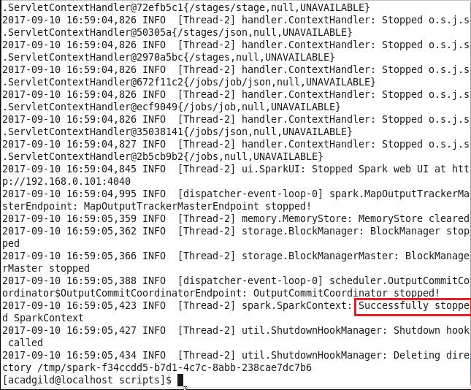

**Below screenshots show the output of hive tables using spark**

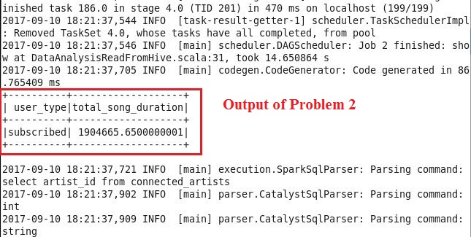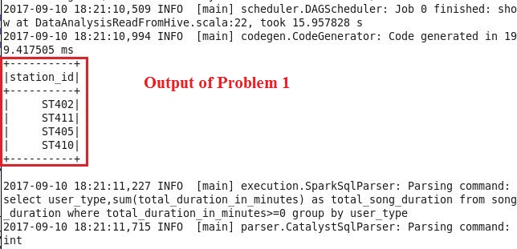

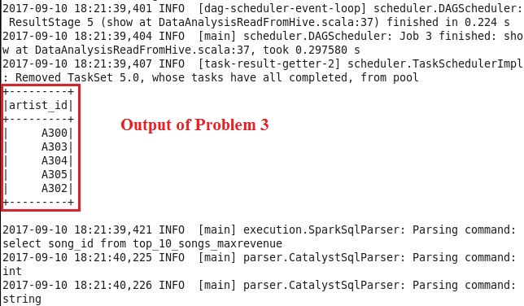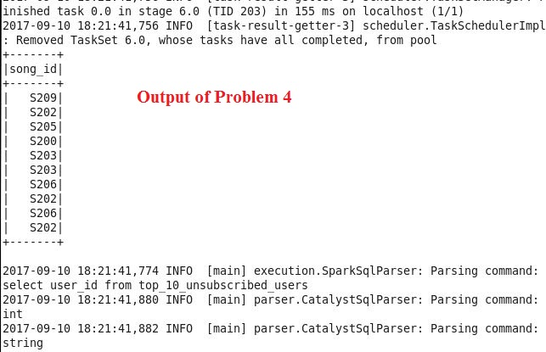

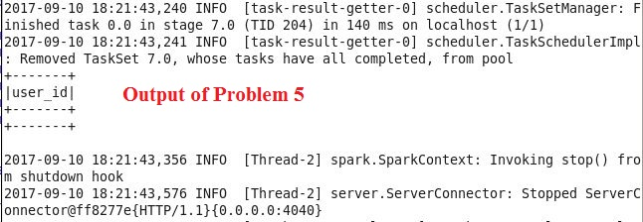

**Below screenshot shows that for all 5 problems of data analysis, five tables created successfully inside hive**

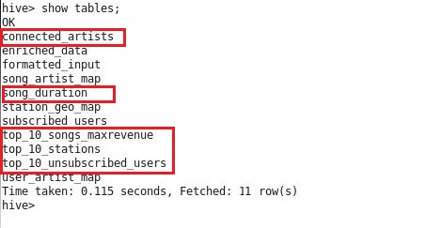

**Output of Problem 1 shown in hive**

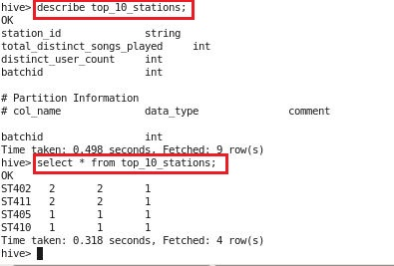

**Output of Problem 2 shown in hive**

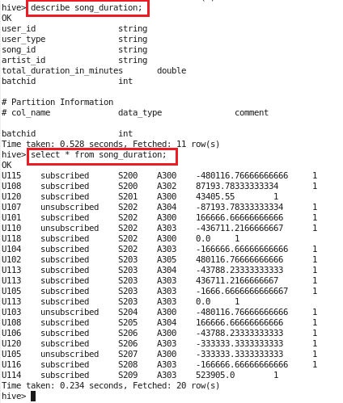

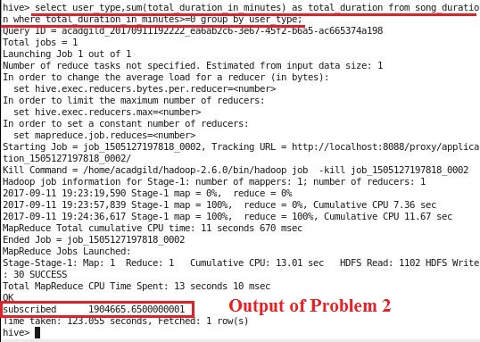

**Output of Problem 3 in Hive**

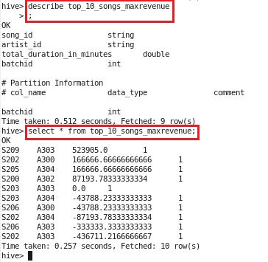



**Output of Problem 4 in Hive**

**Output of Problem 5 in Hive**



1. 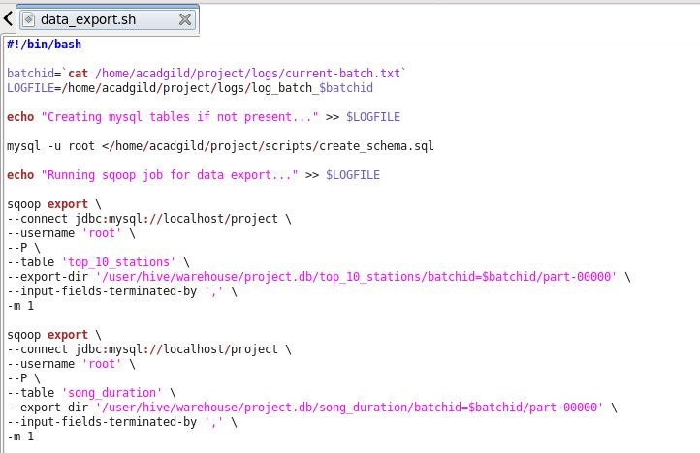 **data_anlaysis_spark.sh calls data_export.sh screenshot of which is as follows:**

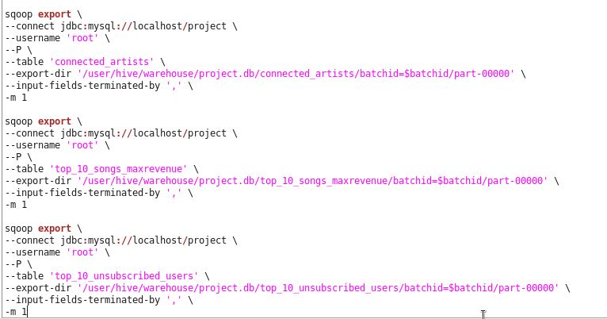

**Above script calls create_schema.sql script, which creates Mysql tables if they don’t exist**

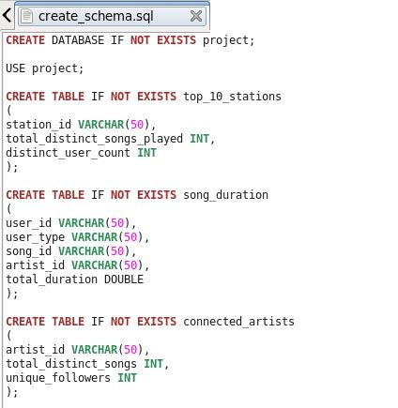

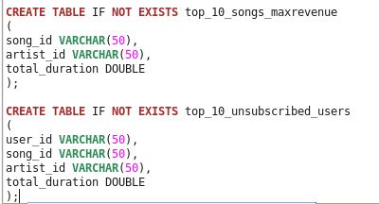

**Below screenshots show that project database and 5 tables got created successfully in mysql**

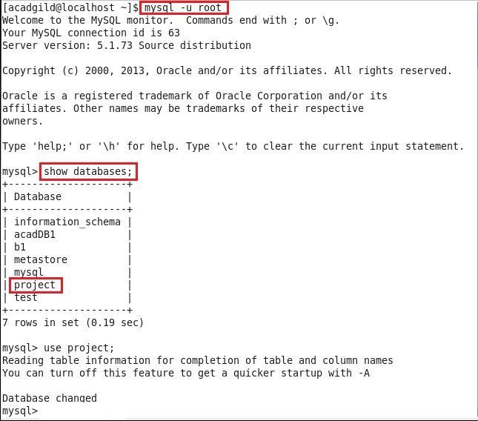

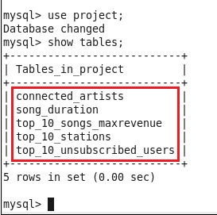

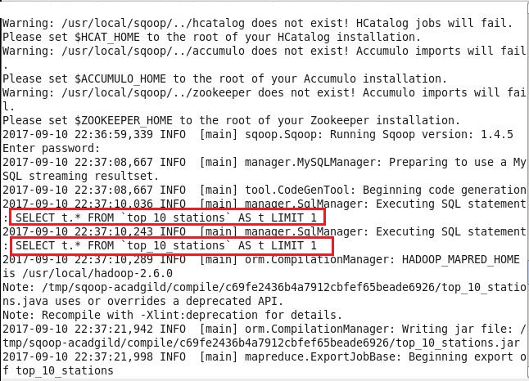**Below screenshots show the execution of data_export.sh**

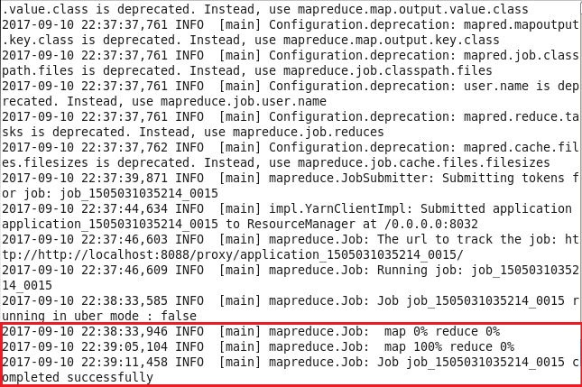

**Below screenshots show that data is inserted successfully from hive tables to mysql tables successfully**

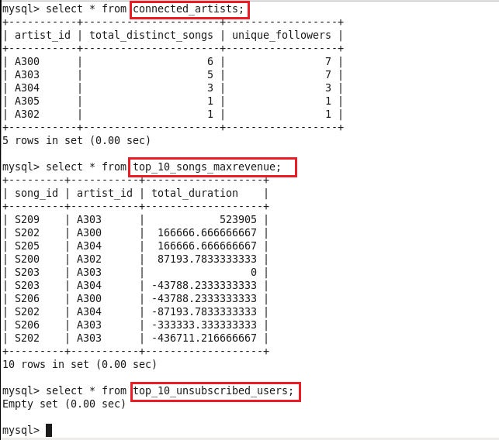

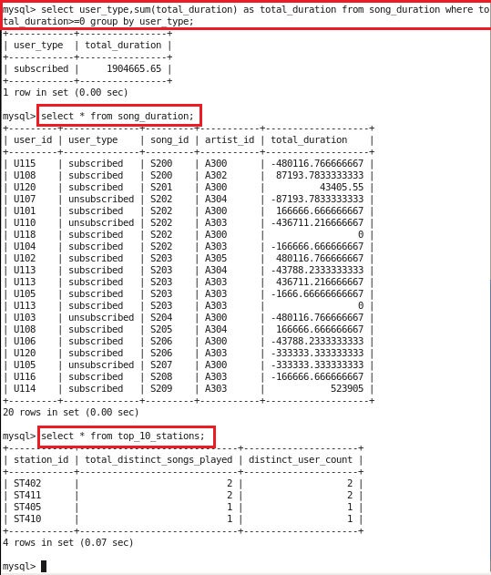

**After successful export of data to mysql, below commands present in data_analysis_spark.sh get executed:**

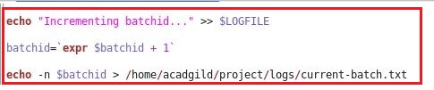



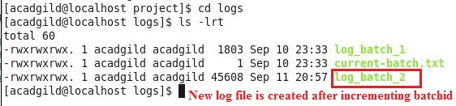

**Contents of log_batch_1 file**

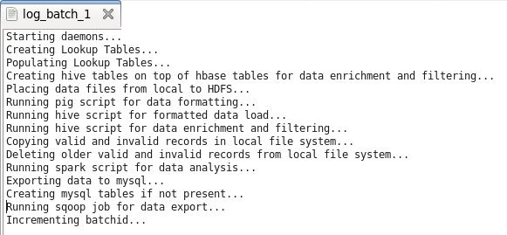

1. **To automate the whole work, i.e. to run all scripts automatically after 3 hours, crontab job is created. Below screenshots show how crontab job is created:**

**Crontab –e is used to create crontab job**

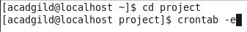

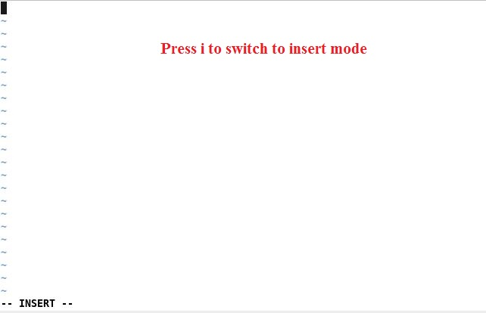

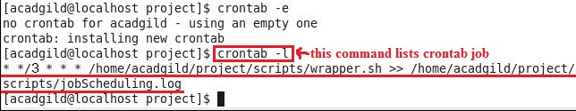 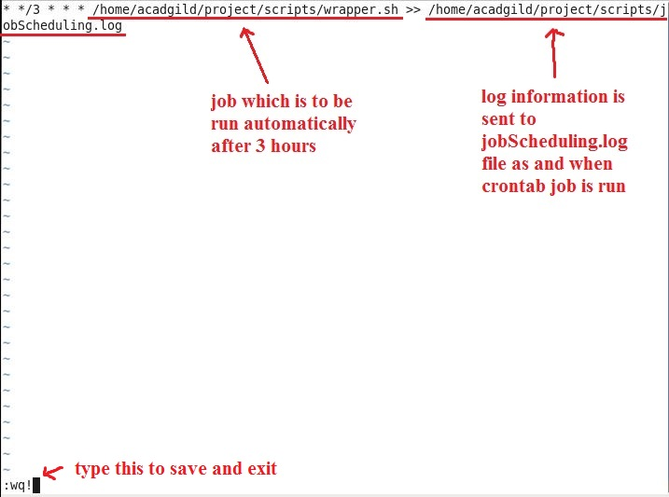

**Future work of this Project**

**In this project, formatting, cleaning, validation steps are done using hive and pig and analysis part is done in spark.**

**So for future work of this project, formatting, cleaning and validation also can be done in spark.**